|  |  |
| --- | --- |
| Name | Hafsa munawar |
| Ag # | 2018-ag-1666 |
| Section | B |
| Github ID |  |

**Assignment week 1**

**Question 1**

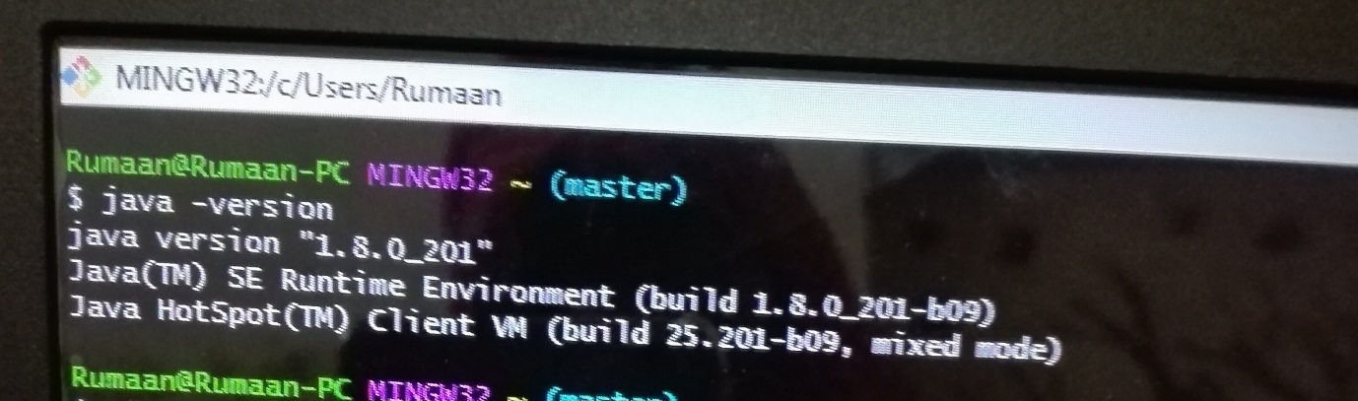

**Question 2**

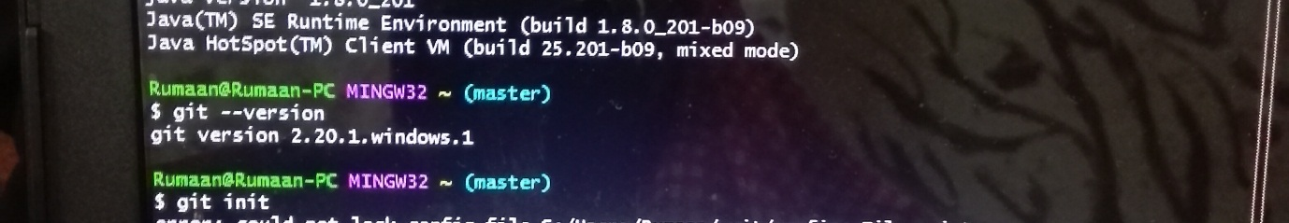

**Question 3**



**Question 4**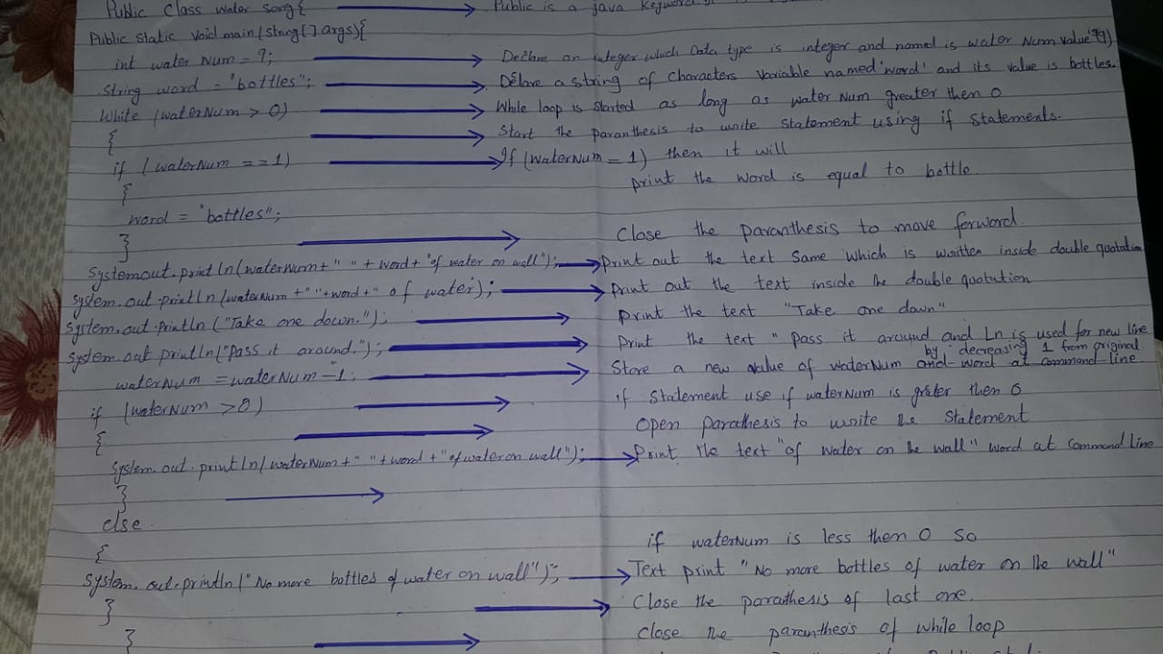

**Question 5**

